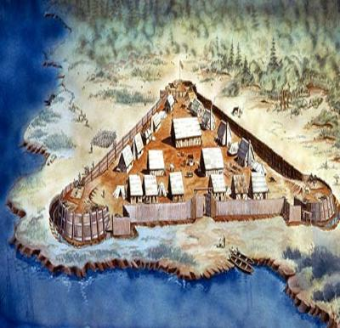

Blood on the River Narrative Ending - A New Ending
This assignment is not a journal entry. It is a chance for you to write an alternate ending to Blood on the River.
Reread the last few pages of the book. Think about how the story ended. Your job is to create a new ending to the story, and then write that ending.
Write 2 to 4 well-developed, carefully thought out paragraphs that flow naturally from a point that you choose from the end of the story. Make sure your ending makes sense based on everything you have learned about in the book.
This is a creative writing assignment – you are expected to be descriptive (use details), use juicy adjectives, vivid verbs, figurative language, and good imagery. Make sure to express emotions and feelings in your writing. Last, your reader should be able to picture what you are writing about. Do Not Just List Event After Event.
Don’t forget to write neatly, use A.R.MS. and C.U.P.S., and show your Kittredge Quality!
Have Fun! I can’t wait to read your narrative ending!

REVIEW THE RUBRIC BEFORE YOU START.

Blood on the River Narrative Ending - A New Ending Rubric
 | Always (1) | Sometimes (.5) | Never (0)
I have written my new ending NEATLY on notebook paper - not in my journal.
I have created an ending that accurately depicts Samuel’s point of view (first person).

My new ending is at least two well-developed paragraphs.
I have written an ending that flows logically from events near the end of the story. (points are doubled for this rubric section) | 2 | 1 | 0
My new ending includes specific details about the characters or story’s events so that the new conclusion makes sense.
I have ended my last paragraph with a takeaway ending.

I have used Show Don’t Tell in my writing.

My ending is descriptive, includes vivid verbs and uses good sensory images.
I included figurative language. I have underlined my figurative language.

I used A.R.M.S. to revise my writing.

I used C.U.P.S. to edit my writing.

I used this rubric to grade myself.

Name___________________ My Score ______ My Teacher’s Score_______

Note: Write your name on this rubric and staple it to your paper.

