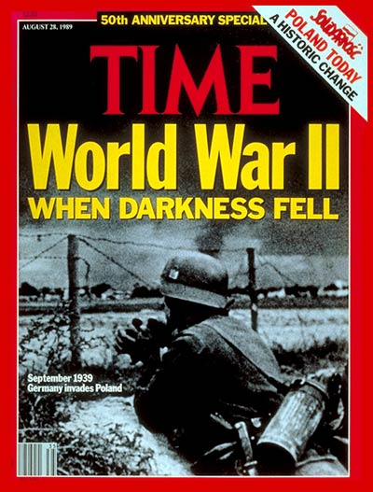
WWII Magazine
What exactly happened during WWII? Was Adolf Hitler really that bad? How did it end?

Do you want to know all the answers to these questions and more? Well you are in the right place! In this project, you will learn about important people, places, and events during World War II. You will learn about German and Japanese aggression prior to the start of the war. You will also learn about Pearl Harbor, Iwo Jima, D-Day, VE/VJ Days, and the Holocaust. You will discuss President Truman's decision to drop the atomic bombs. Furthermore, you will identify FDR, Joseph Stalin, Winston Churchill, Emperor Hirohito, Harry S. Truman, Benito Mussolini, Eleanor Roosevelt, and Adolf Hitler. You will learn about the effects of rationing and the changing role of women (Rosie the Riveter) and African Americans (Tuskegee Airmen). Lastly, you will explain the role the U.S. played in the formation of the United Nations at the conclusion of the war.
By the end of this project, you will be a World War II expert!

Standard: SS5H4 Explain America’s involvement in World War II.
- Describe German aggression in Europe and Japanese aggression in Asia.
- Describe major events in the war in both Europe and the Pacific; include Pearl Harbor, Iwo Jima, D-Day, VE and VJ Days, and the Holocaust.
- Discuss President Truman’s decision to drop the atomic bombs on Hiroshima and Nagasaki.
- Identify Roosevelt, Stalin, Churchill, Hirohito, Truman, Mussolini, and Hitler.
- Describe the effects of rationing and the changing role of women and African Americans or Blacks; include “Rosie the Riveter” and the Tuskegee Airmen.
- Explain the role of Eleanor Roosevelt and the U.S. in the formation of the United Nations.
Task: Your task is to create a magazine, which will be a reflection of the key events of World War II. The date of your publication is to be 1945, at the end of the war. You can handwrite your magazine or create it by using the computer or tablet. However, technology issues are not excuses for incomplete work or misuse of class time.

You may work in groups of two or individually. Student's work will be evaluated individually, based on his/her contribution.

Your finished product is to be in the proper format of a magazine. It should include titles, dates, sections, headings, illustrations, and photographs.
Process: When creating your magazine, you should make sure you include the minimum number of entries from each of the following categories listed below. Remember to write your name on EVERYTHING, and if you are working with a partner you cannot prepare an article on the same topic. Have fun and be creative!

1. Issues: choose four from the list below. Your issues’ article must answer the questions of WHO, WHAT, WHERE, WHEN, WHY, and HOW. The article should be written in your own words, and show evidence of individual research. Accurate dates are a must.

- Germany's Aggression in Europe
- Japanese Aggression in Asia
- Holocaust
- Pearl Harbor
- Iwo Jima
- D Day
- VE Day
- VJ Day
- Atomic Bomb
- Creation of the United Nations

2. Biographies: choose two from the list below. Each biography must emphasize the person's role during WWII, although some background information (minimal) is expected. The articles must be written in your own words and show evidence of individual research.

- Franklin D. Roosevelt
- Joseph Stalin
- Adolf Hitler
- Benito Mussolini
- Winston Churchill
- Hirohito
- Harry S. Truman
- Eleanor Roosevelt

3. Contributions/Events: Choose two from the list below. The contributions section must emphasize the impact/role the subject had on the time period. The articles must be written in your own words and show evidence of individual research.
- Japanese Internment
- Appeasement
- Rationing
- Role of Women (Rosie the Riveter)
- Role of African Americans (Tuskegee Airmen)

4. Images, Ads, & Propaganda: Choose two from the list below. The images, ads, and propaganda pieces must be created by the student. It must have a clear message targeted towards a specific audience. The work must be original, include a picture, and a caption or message. All work must be related to WWII.
- Recruiting Poster
- Political Cartoon
- Map
- Ad from the time period
- Event from the time period
Now you are that you are finished with your magazine, it is time to make it EVEN better. Remember to make sure all articles/pieces contain historically accurate and factual details. The finished project also should contain relevant pictures with appropriate captions. Lastly, you should include scattered advertisements, as well as sports and entertainment articles. Don't forget to go through the writing process! Once you are sure you have completed the requirements, you can add additional elements to your magazine. However, be sure all your added elements are related to WWII.
**Some ideas to add to your magazine are: crossword puzzle, word search, comic, etc…
Resources: Need help finding reliable resources? You came to the right place! Here is list of resources you can use to complete your project.

1. Fifth Grade SS Textbook
2. Library Books
3. World Book Online: You can search for ALL your topics here!
4. Brainpop: You can watch videos and read about some of your topics here.
5. Interactive Notebook
6. Social Studies Weekly: You can read, watch videos, and find photographs here.
Evaluation
Do you want to get an A? Make sure you look over the attached rubric before you get started.

At the conclusion of this project, you will give yourself a score, a friend a score, and then your teacher will give you a score. Since feedback is an important part of learning, you will also think about what you did well and what you need to improve on for next time. These comments will be written in the GLOW and GROW section of you rubric.

World War II Newspaper/Magazine Rubric
Grade your own in pencil, grade a friend using a colored pencil, and the teacher will grade in pen. Add at least two GLOWS, and one GROW when grading.
 | Incomplete or Missing  1 | Meets few expectations  2 | Meets most expectations  3 | Meets or exceeds expectations  4
Two issues that answer the 5 W’s
Two biographies that focus on the role of the person during the war
Two Contributions/Events that emphasizes the impact the subject had on the time period
At least four Images/ Ads, Propaganda that is student created, and relates to WWII
Used time in class wisely and final project shows BEST work
The organization enhances understanding of WWII
Visuals support work-all articles contain a visual and there is a variety of student created and photographs from the time period
Writing is legible and follows proper sentence/paragraph structure
The score I gave myself:
A friend’s score: A friend’s score:
Teacher’s score: GRADE:
GLOWS:

GROWS:

